Micro-CT User Meeting 2021
A paper can be submitted for an oral presentation or a poster presentation. You will receive the approval and selection of the presentation type by September 10, 2021.

☐ By submitting an abstract you are approving that the submitted context is made available on the company website and used for marketing purposes. Please check this box to agree.

We want to thank you already for the effort and hope to welcome you all!

Please send your papers before September 1st, 2021 to usermeeting.BmCT@bruker.com

Paper Title:
Click or tap here to enter the title of your Paper

Presenting Author:
Click here to enter the author’s first and surname

Organization:

Click here to enter the organisation

Address:
Click here to enter the address

E-mail:
Click here to enter your e-mail

Choice of presentation: (click on the checkbox to indicate the type you prefer)

☐ Oral Presentation - ☐ Poster Presentation
This is the Title of my Paper in Arial 14pt

M.Y. Name¹, C.O. Author²

¹Organization, address organization, my.name@organization.com
²Other organization, address organization

Aims
The following are instructions for the format of the paper to be submitted for the Micro-CT User Meeting 2021. The format requirements are kept as simple as possible. Consistent format of submitted abstracts and papers will allow Bruker microCT to place these documents directly in the user-meeting literature without the need to reformat them.

Method
A paper can be seen as an extended abstract of minimum 2-pages including at least some pictures, and possibly tables and results… or what you think is necessary to make your work more clear to understand by a general micro-CT user.

The language should be English. The title should not be too long, avoid abbreviations of technical terms within one specialized field – spell out the term instead. It should be understood by readers from any scientific area. Below the title the authors and co-authors names are written. Please underline the author who will present the paper. Affiliations of the authors should include the institute and short address of each author. Divide the paper into the following sections: Aims, method, results, and conclusions.

In order to avoid formatting problems you can use this document for entering your text. You need to send the paper as a MS Word doc-file. PDF’s cannot be accepted since we need to put all the papers in one book.

Include your references at the end of the paper without using endnotes or footnotes¹

Results
Select A5 as the page default. Use the margin setup with the top, and bottom having a length of 1.4 cm (1 inch), and the left and right margins having a length of 1.5 cm. Please use the Arial font, 8 points for the main text. The title should be set to Arial 14 points (normal, not bold, centered). Include tables and pictures to show the results that you obtained.

Figure 1: Bruker microCT buildings located Kontich - Belgium

Please note when making the paper and your presentation (oral or poster) that the Micro-CT User Meeting has an audience with different backgrounds and interests. Keep your presentation general and don't assume that your standard abbreviations will be understood by everyone. It would be interesting to explain your research so that a general audience would understand it. The main focus should be on what you do with the micro-CT and the images.

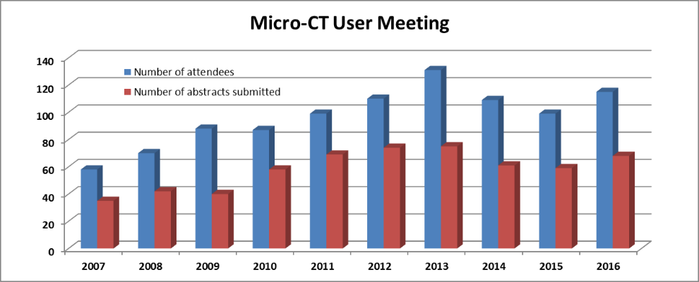

Figure 2: Evolution of number of attendees and submitted abstracts.

Conclusion
We hope to welcome you at the Micro-CT User Meeting with an oral or poster presentation and look forward to receiving your submissions for our annual picture and movie contest, an opportunity to win great prices.

References:
- Author, “title” Journal, Pages, year
- Author, “title” Journal, Pages, year

